Descriptions of Brain Testing

I have Used MSSQL, ASP.NET, WPF and The main language is C #.

The database:

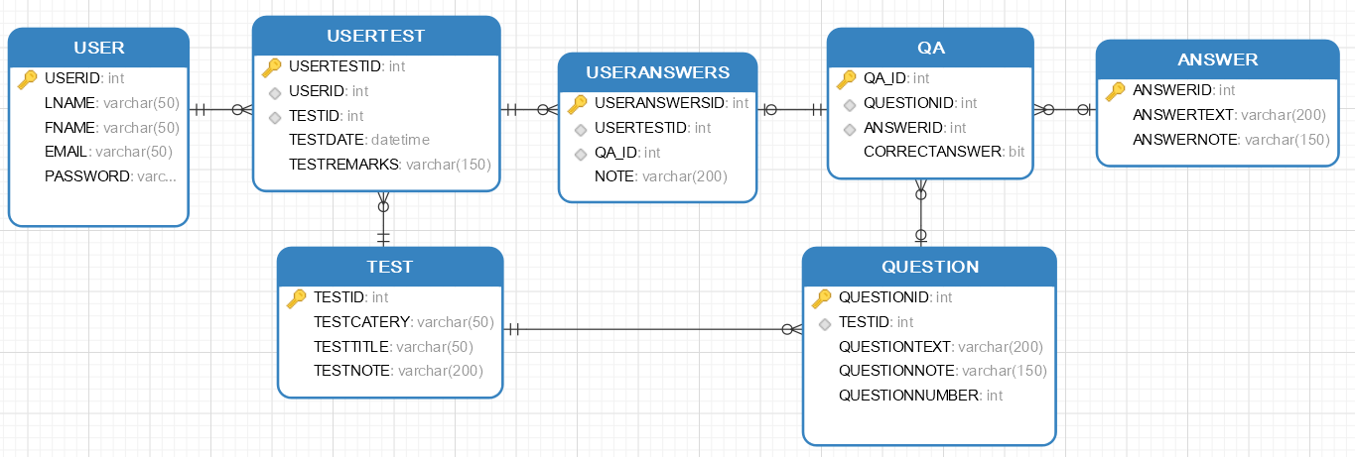

The project consists of two components: a desktop application for the administrator and a public site.

The database is connected to the project using EntityFramework 6, the Code-First method ( each table is described by a class, and they are all connected by a class describing the database).

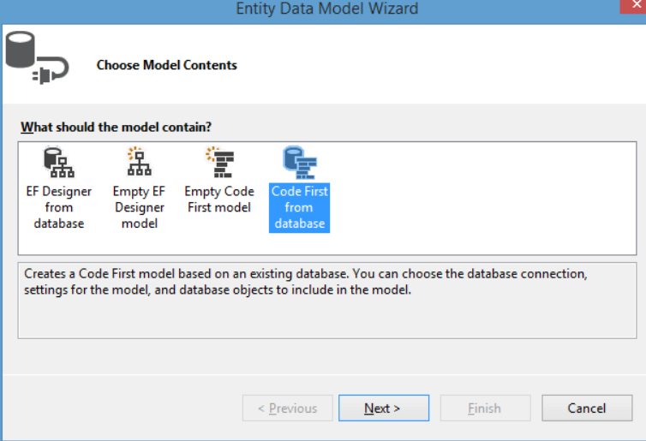

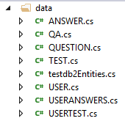

Class for table TEST

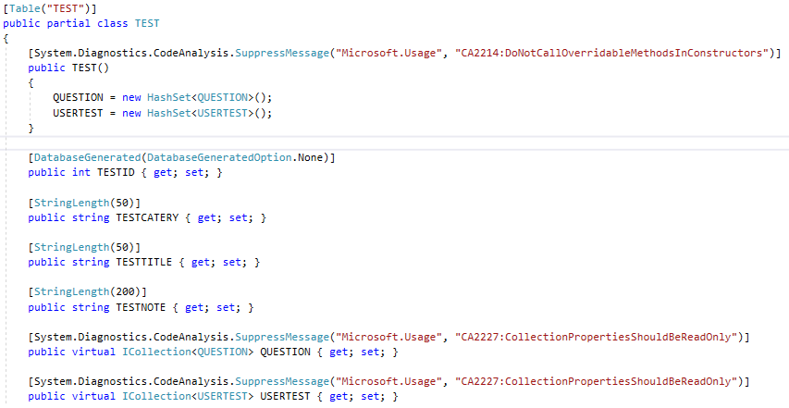

Class for DB

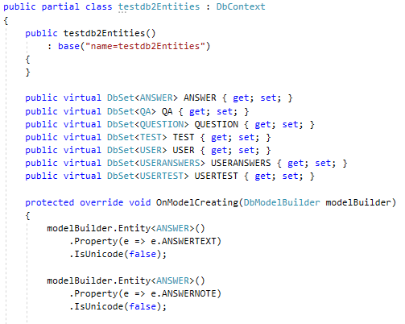

1. **Desktop**

When opened, a list of all tests is shown (ShowTests.xaml).

Buttons:

Add test - add test (its name)

Show results - display of test passing results.

Show users - work with the list of users

Edit - edit test contents, i.e. questions and answers.

Remove– remove the test.

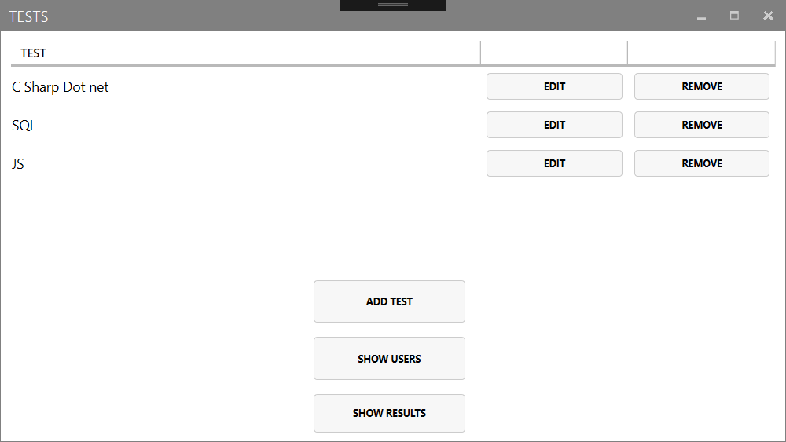

(AddTest.xaml):

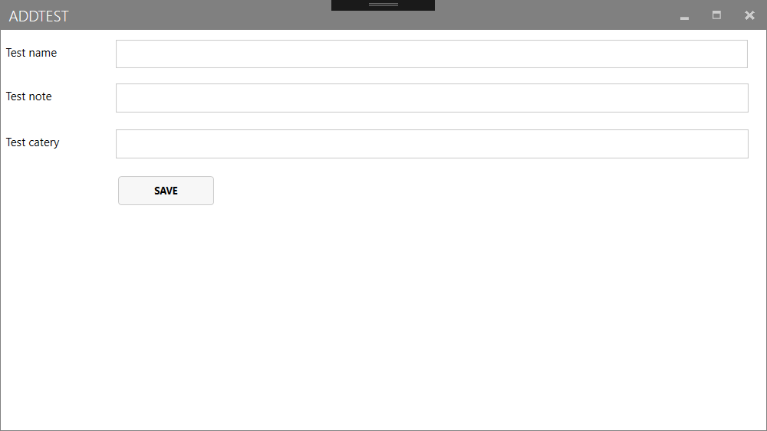

(ShowResults.xaml):

The top table shows a list of all the answers for each test pass, and the bottom one shows only the scores for each pass.

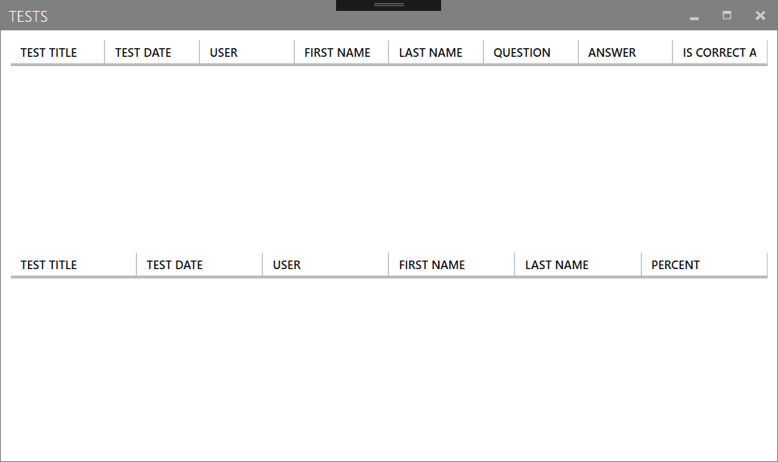

Users: ShowUsers.xaml

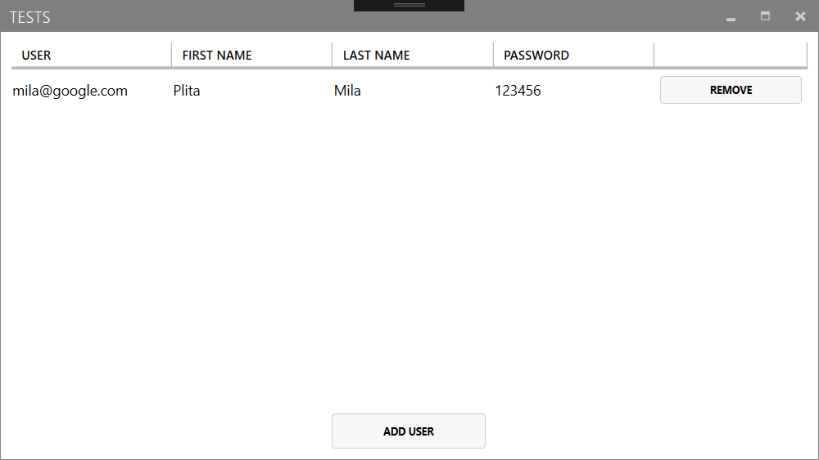

Add user AddUser.xaml

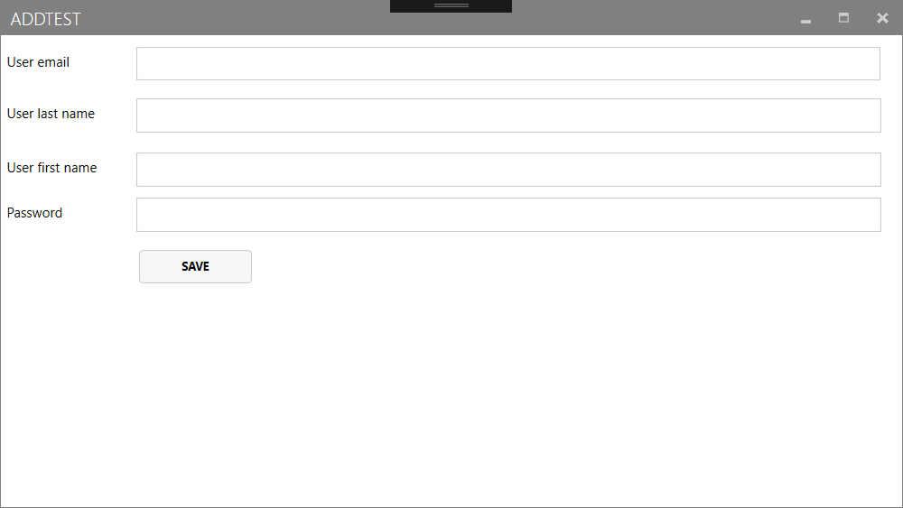

(ShowQuestions.xaml):

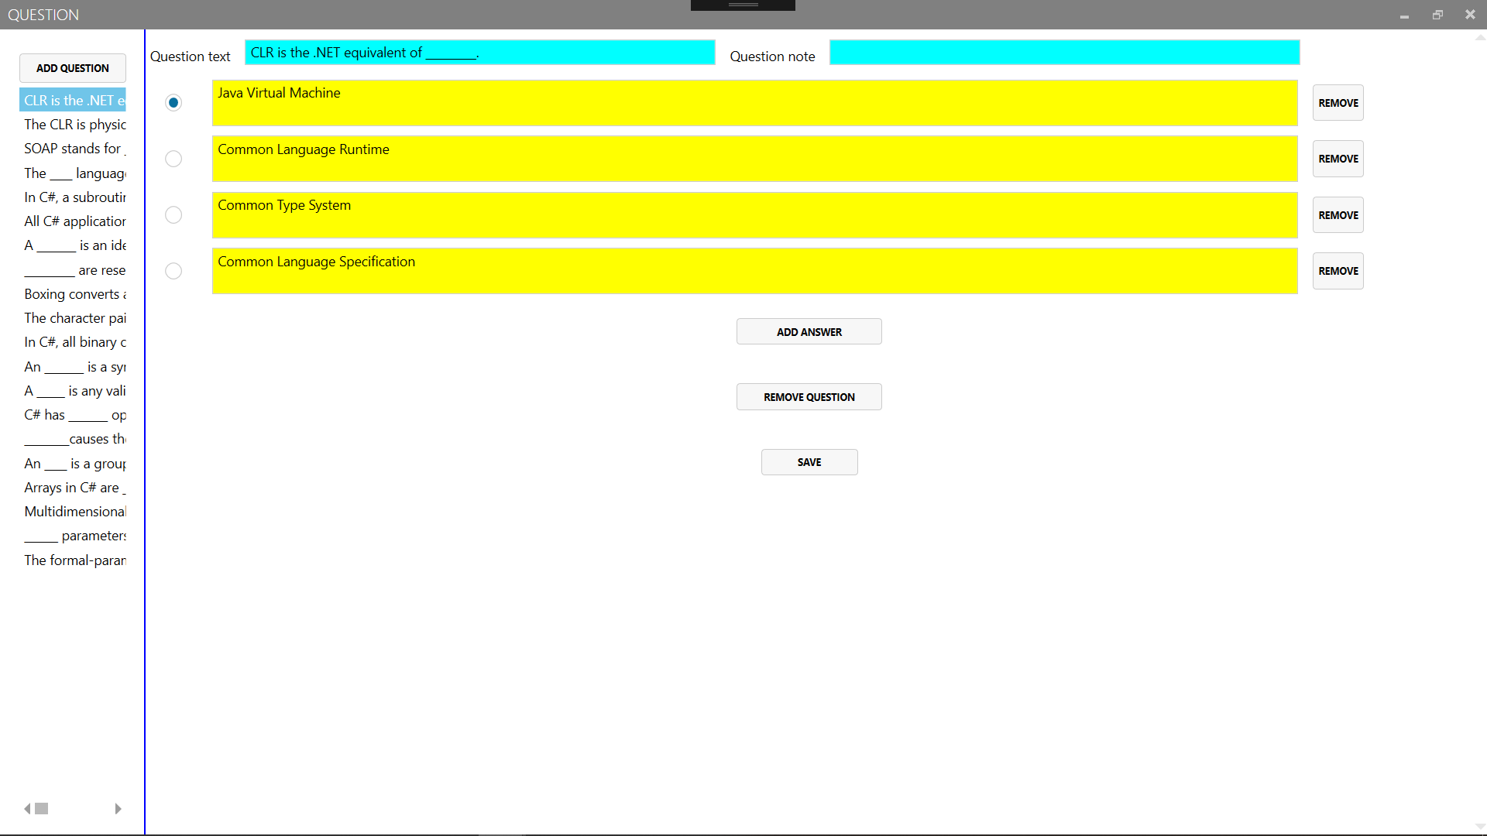

An unlimited number of questions and answers can be added. By clicking on the text of the question in the left column, the right side opens its contents for reading and editing.

1. **Site**

Classes that are not related to the database and pages:



When you try to go to any page, except the default, there will be a check on the user's authorization. If the user is not authorized, he will be transferred to the login page.

Login.aspx - login page

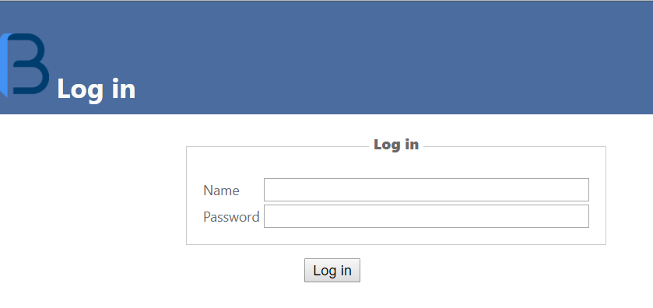

Defeault.aspx – the main page

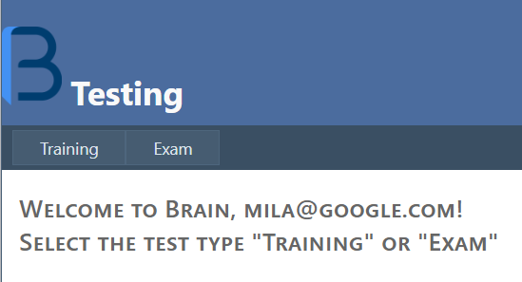

ListTrialTest.aspx training tests

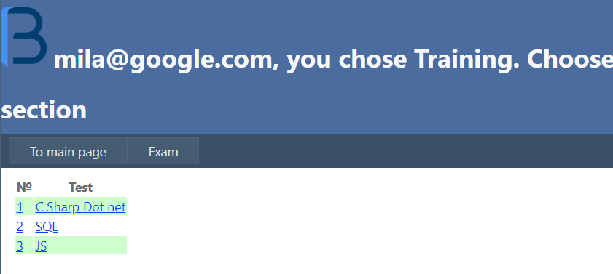

TrialTestQuestion.aspx

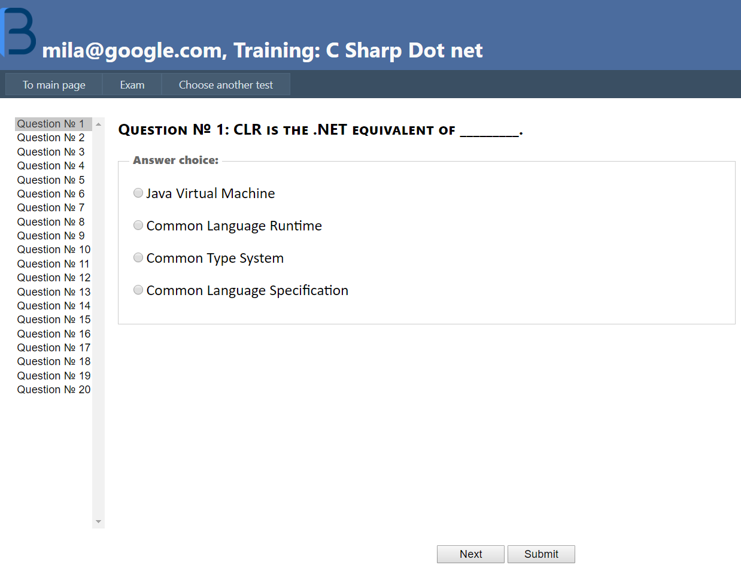

TrialTestQuestion.aspx after submit:

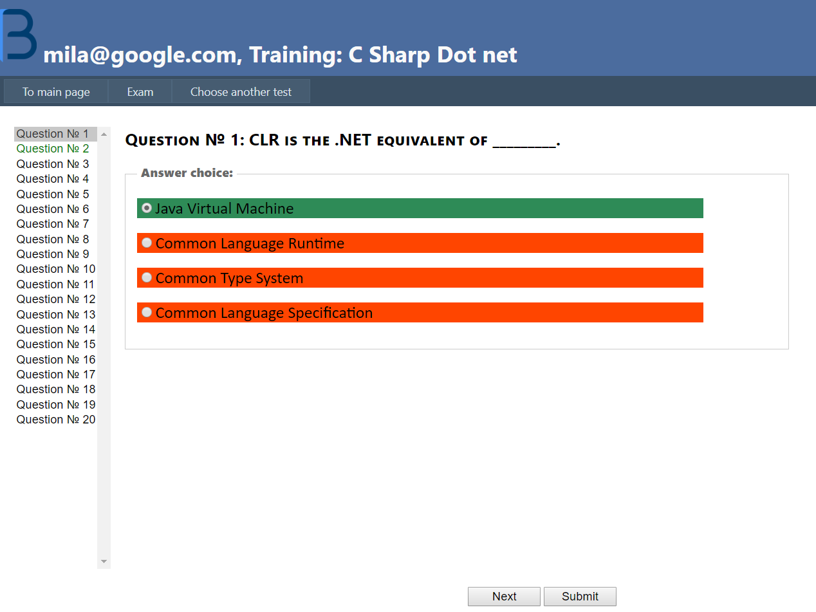

Only after clicking on Next is the transition to the next question.

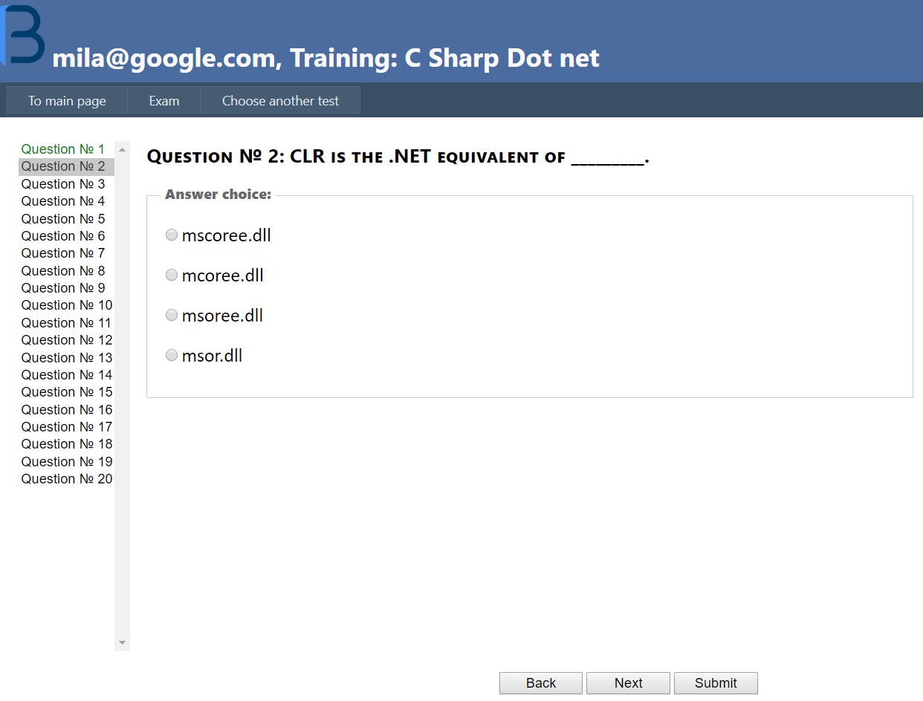

ExamQuestion.aspx – exam

